UNITED  NATIONS |  | BC  UNEP/CHW/CLI_EWG.2/INF/8
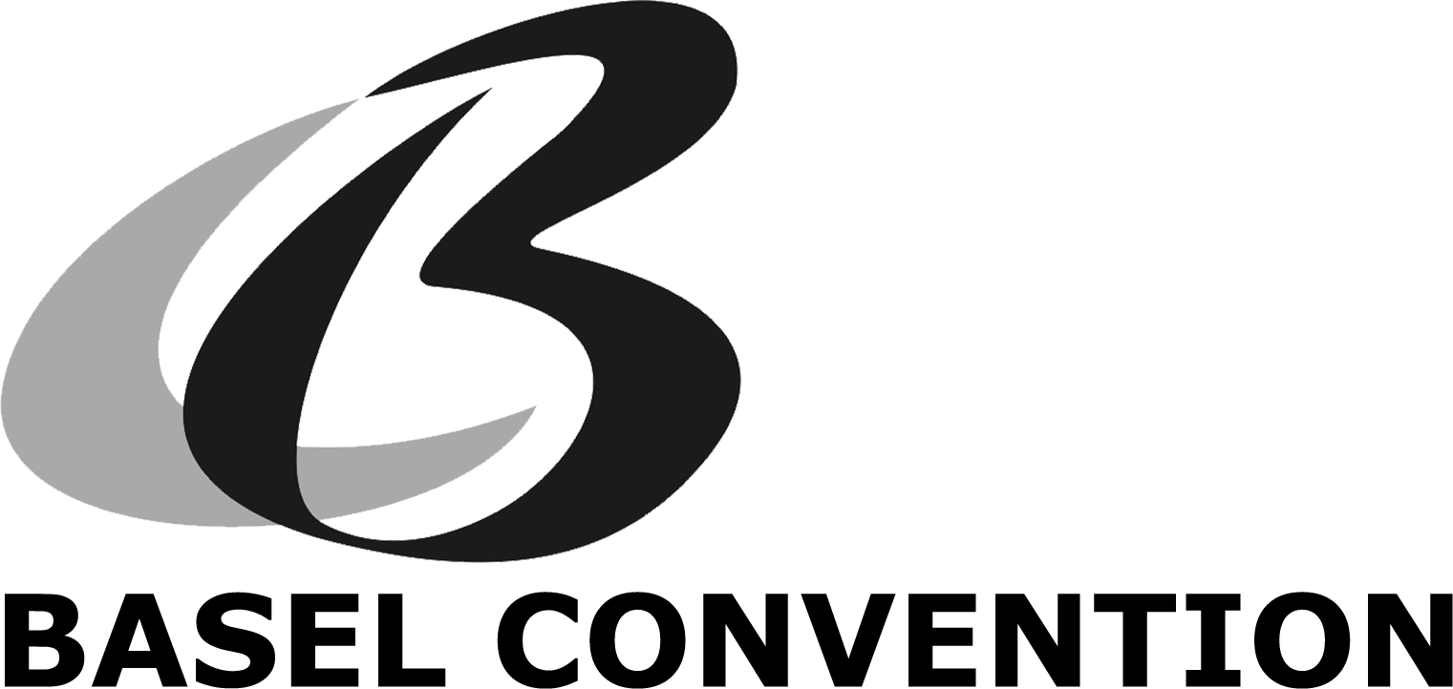 |  | Distr.: General  21 May 2014  English only
Expert Working Group on Environmentally Sound Management
Second meeting
Jakarta, Indonesia, 29−31 May 2014
Item 3 (b) of the provisional agenda∗
Consideration and further development of work commenced
during the intersessional period: development of practical manuals
Draft practical manual: Licenses / Permits
Note by the Secretariat

1. The terms of reference for the expert working group on the framework for the environmentally sound management (ESM) of hazardous wastes and other wastes contained in annex II to decision BC-11/1 requested the expert working group to, among other things, collect available information on national and other ESM standards and practices and to develop generic guidance on how to establish ESM. At its first meeting, the expert working group decided to work intersessionally to develop practical manuals on key topical areas of environmentally sound management. The group agreed to develop manuals on the following topics:

(a) Terminology;

(b) Principles / General Rules and Model Legislation;

(c) Licenses / Permits;

(d) Safety and Insurance / Liability;

(e) Certification Schemes;

(f) Prevention.
2. The annex to the present note contains the draft practical manual developed by the small group on licenses and permits. This information has not been formally edited by the Secretariat and is presented as received.

Annex

Permits and Licenses

A Practical Manual for Promotion of the Environmentally Sound Management of Wastes

Introduction
Basel
Convention

- Purpose
The permitting and control of installations and activities by competent authorities is essential for ensuring the environmentally sound management of hazardous waste and other waste. This manual provides information on the necessary procedures and requirements in relation to permits and monitoring.

- Addressees
This manual is aimed at all groups of stakeholders who are responsible for ensuring the environmentally sound management of wastes: legislators, authorities, waste management operators and civil society. The exchange of information and cooperation between these stakeholders is essential in order to reach improved standards in waste management.

- How to use the manual
This manual provides a general overview of the procedures and requirements for obtaining a license or a permit to conduct waste management activities and how to ensure environmentally sound management. Most important is the incorporation of these general rules into national legislation, and their practical implementation. Only when higher standards for waste management are promoted over lower, inadequate standards, can the necessary investments be made by facilities and other stakeholders. Therefore, it is of the greatest importance to enable the main actors to access the necessary information: this manual provides an overview of the necessary information with some references.

- Short terminology
Permit and license; approval; application; competent authority; management; treatment; requirements; planning; monitoring)-to be sent to the Group on Terminology

Permits / Licenses

1. Permit/license requirements

Waste management facilities should hold a permit, license, or other authorization for legal operation. A permit shall be required on the basis of relevant national legislation for storage, recovery, preparation prior to recovery or disposal of waste. For collection and transport of waste only a registration may be required. Permits/licenses and registrations should be obtained in accordance with national, regional, or state legislation which should clearly state the process by which (and through whom) one may obtain a permit/license for operation or registration only.
-terminologies need to be defined (permits/licences/registration)-to be sent to the Group on Terminology
- focus on describing the process to get licences; each country has different process and different levels
- step by step procedure and then what are the requirements
- firstly describe (1) the environmental requirements (2) management (3) procedural requirements and then (4) monitoring (facility to comply with requirements and authority control)
- Planning

The operators of waste management facilities shall plan their activities prior to applying for a permit or license. They should be able to demonstrate:

- Waste management plan (for treatment of wastes and waste residuals generated), including:
- A description of how wastes would be stored;
- A description of the waste treatment operations that would be carried out.

- Sufficient measures to safeguard occupational health and safety
Workers at waste management facilities should not be exposed to unacceptable occupational health and safety risks related to the content of the materials they are handling, emissions from those materials and the equipment being used. The waste may include hazardous chemicals or toxic metals; it may generate emissions or release harmful dust. Workers may have to handle heavy loads, be exposed to vibrations and the noise of machinery. Also, the risk of fire and explosion may exist in some cases. Consequently, adequate measures should be taken to avoid unacceptable occupational health and safety risks. Adequate measures may include the implementation of national as well as international regulations, agreements, principles and standards, whether mandatory or voluntary.

- Appropriate and adequate emergency plan
The facility should have a regularly updated plan for monitoring, reporting and responding to accidental or otherwise exceptional pollutant releases, including emergencies such as accidents, fires, explosion, abnormal operating conditions, etc. The emergency plan should be based on the evaluation of existing and potential risks. This plan should be regularly tested and revised as appropriate, in particular after the occurrence of accidents or emergency situations.

- Training programme for personnel
Personnel involved in the management of waste and materials, in particular hazardous waste and materials, should be capable and adequately trained to be able to identify and properly handle the materials, operate equipment and follow processes, eliminate risk situations, control releases and carry out safety and emergency procedures.

- Monitoring and reporting programme
The facility should have a monitoring and reporting programme which covers:
- relevant legal requirements, including key process parameters;
- compliance with applicable safety requirements;
- effluents and emissions; and
- incoming, stored and outgoing waste, in particular hazardous waste.

Waste management facilities should maintain records on the generation, collection, recovery or disposal of waste, its type and amounts. These records are to be made available to the competent authorities upon request.

- Plan for closure and after-care
Generally, the facility should have an adequate plan for closure and aftercare. The need for closure plans and financial guarantees is determined by applicable laws and regulations, taking into consideration the level of risk. Closure plans should be updated periodically and financial guarantees should ensure that necessary measures are undertaken upon definite cessation of activities to prevent any environmental damage and return the site of operation to a satisfactory state, as required by the applicable laws and regulations.

- Financial assurance for:
- liabilities from accidents, emergency spills, and/or clean-up;
- closure and after-care
- public involvement including public meetings and public review and comment periods on the draft permit application.

3. Application

  - The permit shall be issued to persons registered as waste facility operators within the provisions of the relevant national legislation;

b) The persons who apply for a permit shall submit an application stating the following:
- Name of the company, registered office, management address;
- Location of the waste management site;
- Type (e.g. Basel code and name), quantity and origin of waste to be treated;
- Waste management operations for which the application is filed;
- Methods and technologies that will be applied, including the best available technologies;
- Indication of emissions and resulting waste streams (type, description, quantities and destinations) to be expected;
- Description of the installations that will be used as well as their capacity;
- Safety and precautionary measures that will be taken;
- Measures and technologies for closure operations at waste treatment sites.

c) The application shall be submitted to the competent authority in the appropriate format.

4. Approval process

Waste management facilities may only be operated if the operator holds a permit containing requirements, and is in compliance with these requirements, for the protection of air, water and soil, waste minimisation, accident prevention, site clean-up, and any other matters specified in the permit.

The competent authorities shall:
    - Decide whether the application and its accompanying documentation comply with the requirements, including assessment of the implementation of best available techniques if required by national law;
    - Conduct or require an environmental impact assessment as part of the permit application review process if called for by national laws;
    - Make an assessment of appropriate action to be taken in case of unacceptable emissions arising from the facility’s operations;
    - Inspect the site and discuss details with the applying person;
    - Consult with other authorities and the public in order to gather facts and opinions that would contribute to the assessment of the application;
    - Issue or refuse to issue the permit;
    - Lay down specific conditions, other than the general conditions laid down in regulations, for carrying out waste-related operations with a view to ensuring compliance with the requirements.

It is important to set time limits for each stage of the procedure. Time limits will lead to reduced costs for applicants and ensure competent authorities are accountable and efficient.

5. Change/cancellation/termination of permits

- The permit shall be issued for a set period of time;
- The permit can be amended or supplemented as deemed necessary by the competent authority or upon request from the permit holder;
- The permit operations shall be terminated:
- after the expiration date;
- by competent authority decision (if violations are found);
- if the permit holder requests.

Requirements

This section provides examples of requirements that are generally addressed for the environmentally sound management of waste. Many countries take different approaches to establishing requirements in order to determine what may constitute environmentally sound management of waste. A variety of conditions may dictate specific requirements such as the type and quantity of waste, the size and type of facility, the manner of treatment, storage, recovery, or disposal of the waste,[ climate conditions, proximity to population, assessment of risk, etc.](may not be suitable here)

Emissions

1. Air (especially in case of thermal processing)
- Thresholds: CO, SO_{x}, NO_{x}, fine dust, HCl, dioxins and furans, Hg, heavy metals;
- Quantities and concentration of contaminants in the ashes due for final disposal in landfill.

2. Water
  - categorizing of discharged water/fluids and receiving medium (water body, sewer, water treatment plant…);
  - thresholds: floating substances, Hg, Cd, As, Pb, Cr, Cu, Ni, Zn, dioxins and furans;
  - conditions for waste water from flue gas cleaning.

3. Soil
  - Thresholds of contaminants in the effluent for final disposal (for wastewater treatment) and in the ashes for thermal treatment.

4. Other (odor, light, noise…)
- There should be requirements for minimization of odor, light and noise and these should be part of the ERP submitted by the applicant to the competent authority.
Additional requirements

5. Facility requirements
- Depending on the management method, type of waste being treated, etc., facility requirements should be established by the competent authority.(Note: this idea may be moved and described in the beginning of this document)

6. Positioning/spatial planning
- Proper positioning and planning of the facility shall be assessed by superimposing the spatial location on other maps such as road, rail, water supply, residences, community services, etc.

7. BAT/BEP (State of the Art Technology)
- [Evidence should be provided by the applicant to ascertain that the technology in use is the best available to date, and also the process being utilized is best and environmentally friendly.]Note: not part of the permitting process

8. Occupational Health and Safety Requirements:
- Hygiene and nuisance control;
- Measuring and data registration duties;
- General duty to inform and specific reporting duties;
- Protective measures towards soil and environment;
- Facilitate periodic medical examination for employees.

9. Corporate environmental care
- Facilitate training of the employees of the waste facilities;
- Facilitate review and updating of the procedures periodically as new information becomes available;
- Constitute auditing committees for different environmental issues.

10. Waste operation requirements
- Criteria for acceptance of waste at the facility;
- Monitoring: standardized sampling and test methods;
- Downstream waste management of residual wastes;
- Storage of hazardous substances, e.g. rules on distance, compatibility, etc.

Monitoring and control

2.Control (by authorities)
On a periodic basis, in accordance with national and/or state/regional laws, relevant authorities shall inspect the facility(ies) for which the permit has been issued to verify compliance of the conditions for waste management with those stated in the permit issued and compliance with the requirements of the national waste management requirements.

1.Measurement of emissions / emissions (by facilities)
Obligation to provide information and reports. All relevant environmental records should be maintained and made available to relevant authorities according to national legislation and/or local authorisation/license/permit requirements.
3.Enforcement (by authorities)
    - Follow-up actions in case of non-compliance

____________________

∗ UNEP/CHW/CLI_EWG.2/1.

